Name: Ishaan Vijaykumar Dhore
PRN: 126224310
Roll no.: 29
Panel: G


School of Computer Science and Engineering Department of Computer Engineering and Technology
S. Y. B. Tech CSE AY 2026-27 Semester: 3 Computer Networks Lab (CSE40110)
Assignment No.: 7
Title: DHCP, DNS, Web Server and Email configuration in cisco packet tracer.

Aim: DHCP, DNS and Web Server configuration (Use: Packet Tracer/GNS). Configure network using Dynamic Host Configuration Protocol (DHCP), DNA and Web Server Use Ping utility to test connectivity.
Objectives: To learn the DHCP, DNS and Web Server installation and understand their practical usage.

Theory:

Dynamic Host Configuration Protocol (DHCP)
DHCP is an application layer protocol that gives IP configuration to hosts automatically. A DHCP server hands out an IP address, subnet mask, default gateway, DNS server address and a lease time. It uses UDP port 67 on the server and UDP port 68 on the client. Without DHCP, an administrator must set every host by hand. That is slow, and one duplicate or mistyped address breaks connectivity. DHCP removes this work, avoids address conflicts, reuses addresses when hosts leave (through lease expiry) and lets a change such as a new gateway be made once on the server. The exchange is Discover, Offer, Request, Acknowledge (DORA).

DNS (Domain Name System)
DNS maps human readable names such as www.mitwpu.edu to IP addresses. It is a distributed, hierarchical database (root, TLD, authoritative servers) that uses UDP/TCP port 53. Data is stored as resource records (RR): A (name to IPv4), AAAA (name to IPv6), CNAME (alias to canonical name), NS (authoritative name server of a zone), MX (mail server of a domain), PTR (IP to name), SOA (start of authority, zone details) and TXT (free text, e.g. SPF).
Recursive lookup: the client asks its resolver for the final answer. The resolver does all the work and returns either the IP address or an error. Iterative lookup: a server never chases the answer. It replies with the best answer it has or a referral to another server. For www.mitwpu.edu the resolver asks a root server (referral to .edu servers), then a .edu server (referral to the mitwpu.edu name server), then that server, which returns the A record. Usually the client-to-resolver step is recursive and the resolver-to-server steps are iterative.

SMTP, POP3 and IMAP
SMTP (Simple Mail Transfer Protocol) pushes mail from a client to a mail server and between mail servers. It is a push protocol. Ports: 25 (server to server), 587 (client submission with STARTTLS), 465 (SMTP over SSL). POP3 (Post Office Protocol v3) pulls mail from the server to one device, and by default deletes it from the server after download. Ports: 110 (plain), 995 (SSL/TLS). IMAP (Internet Message Access Protocol) lets the client read and manage mail on the server, so folders, read flags and messages stay in sync across devices. Ports: 143 (plain), 993 (SSL/TLS).

Design Screenshots:
Topology built in Cisco Packet Tracer: one router, one switch, three PCs set to DHCP and one server (Server0) that runs the DHCP, DNS, HTTP and Email services.
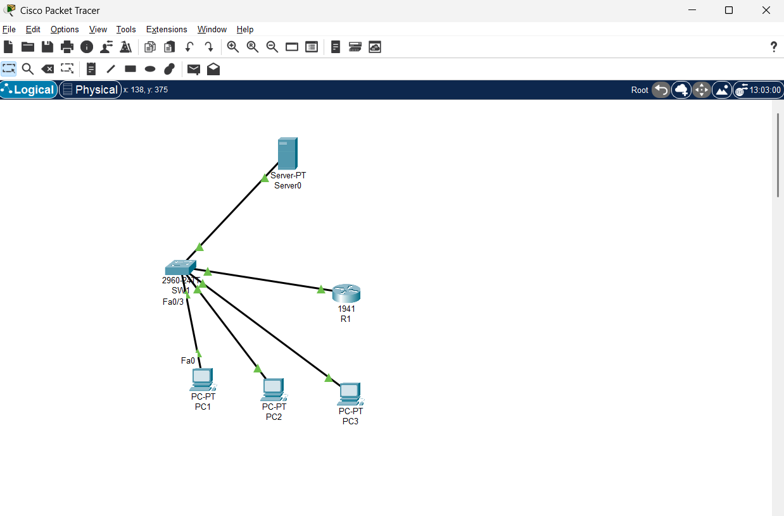

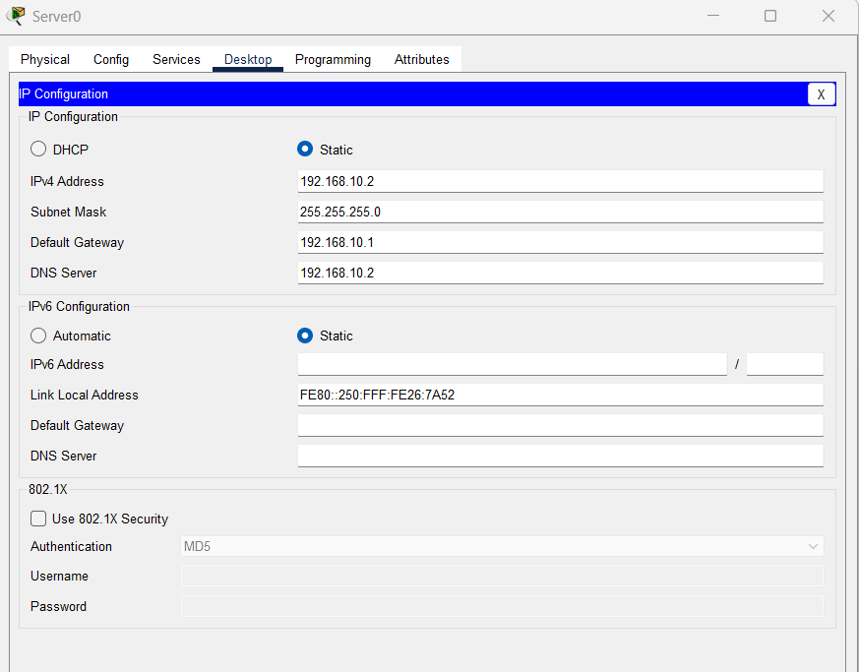
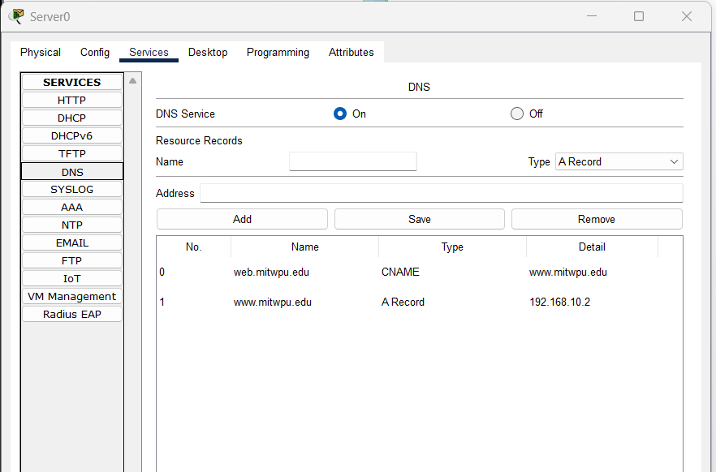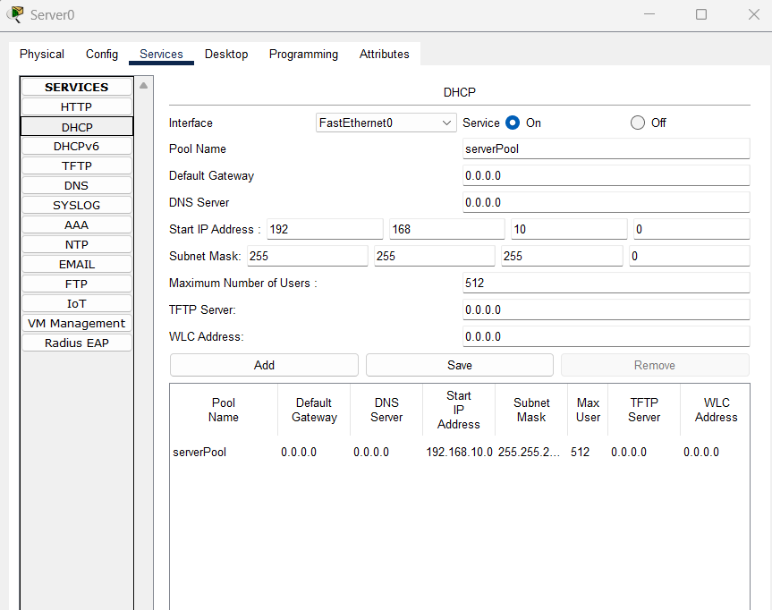
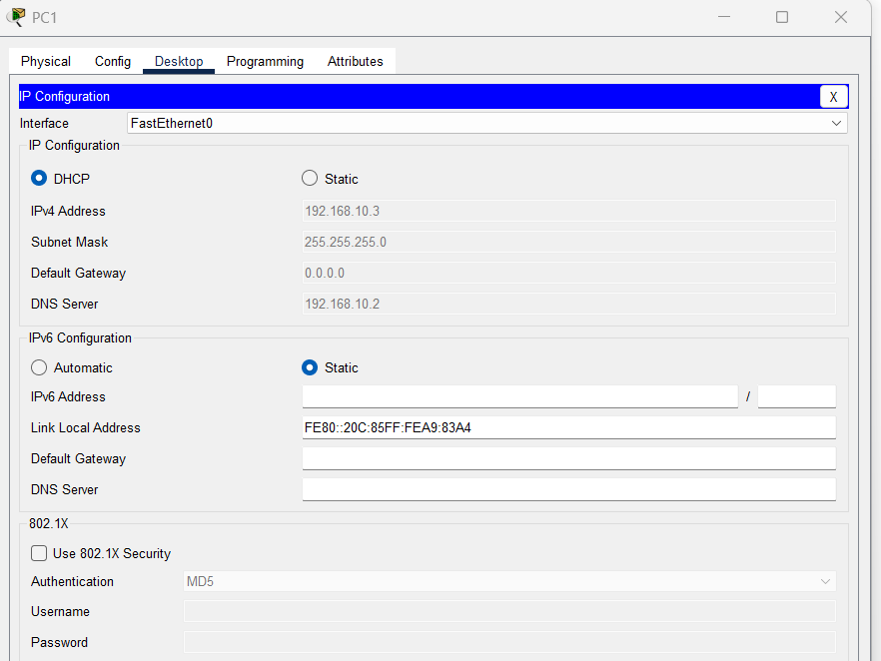
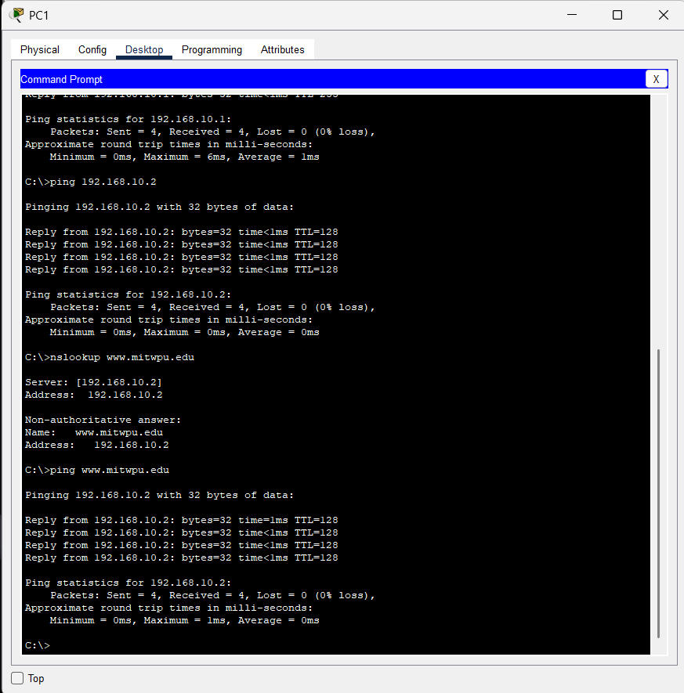
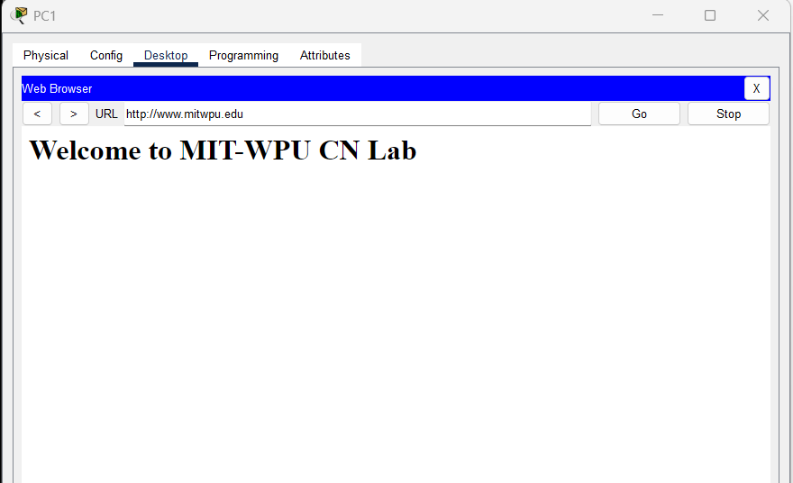

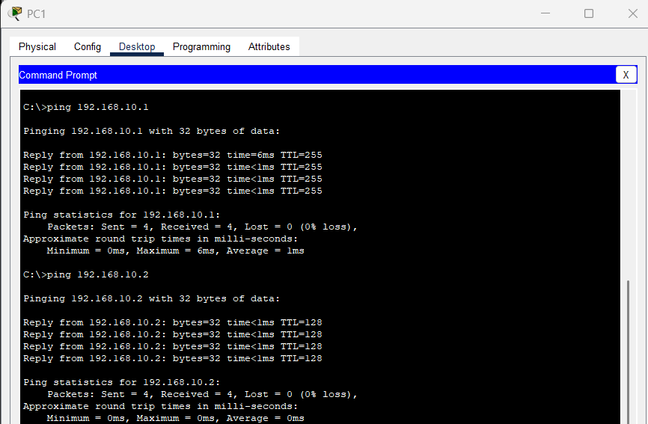
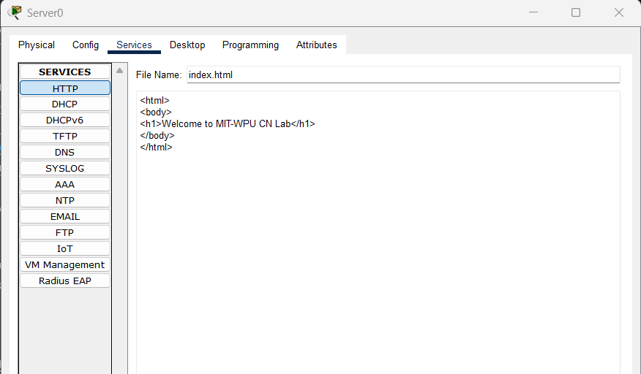

Output Screenshots:

1. DHCP Configuration and Verification
The DHCP service was enabled on Server0 with the following configuration:
- Server IP Address: 192.168.10.2
- Subnet Mask: 255.255.255.0
- DHCP Pool Name: serverPool
- Starting IP Address: 192.168.10.10
- DNS Server Address: 192.168.10.2
- Maximum Number of Users: 512
The PCs were configured to obtain their IP addresses automatically using DHCP. PC1 received IP address 192.168.10.3 with subnet mask 255.255.255.0.

2. Network Connectivity Test
The following commands were executed from the PC command prompt:
ping 192.168.10.1
ping 192.168.10.2
Observed result: Both tests received 4 replies, with 0% packet loss. This confirmed connectivity to the gateway and the server.

3. DNS Configuration and Verification
The DNS service was enabled on Server0, and the following records were configured:
Name | Record Type | Value
www.mitwpu.edu | A | 192.168.10.2
web.mitwpu.edu | CNAME | www.mitwpu.edu

Observed result: DNS resolution returned IP address 192.168.10.2, and the ping test received 4 replies with 0% packet loss.

4. Web Server Configuration and Verification
The HTTP service was enabled on Server0, and the default web page was edited to display:
Welcome to MIT-WPU CN Lab

Students Observation:
- PC1, PC2 and PC3 received IP addresses automatically from Server0 (192.168.10.10, .11, .12) in sequence, along with mask, gateway and DNS server. No manual entry was needed on the PCs.
- The server and router interface use static addresses because they provide services and the DHCP pool starts at 192.168.10.10, so there is no clash.
- Ping from every PC to the router (192.168.10.1), to the server (192.168.10.2) and between PCs gave 0% loss.
- The name www.mitwpu.edu resolved to 192.168.10.2 through the DNS A record, and the web page opened in the browser over HTTP (port 80).
- User1 sent a mail to user2 through SMTP and user2 downloaded it through POP3, which confirms the email service works.
- When the DHCP service was turned off and a PC was renewed, the PC fell back to an APIPA address (169.254.x.x) and could not reach the server. This shows why DHCP is needed.

FAQ
  - What are the different DHCP messages involved in the dynamic IP address allocation process?
Message | Sent by | Purpose
DHCPDISCOVER | Client (broadcast) | Finds available DHCP servers on the network.
DHCPOFFER | Server | Offers an IP address, mask, gateway, DNS and lease time.
DHCPREQUEST | Client (broadcast) | Accepts one offer (and declines others), or renews a lease.
DHCPACK | Server | Confirms the lease and the configuration.
DHCPNAK | Server | Rejects a request (address invalid or already in use).
DHCPDECLINE | Client | Tells the server the offered address is already in use.
DHCPRELEASE | Client | Gives the address back before the lease ends.
DHCPINFORM | Client | Asks for extra settings when the IP is already set manually.
  - Explain the DORA process used by DHCP for dynamic IP address allocation.
    - Discover: a new client has no IP, so it broadcasts from 0.0.0.0:68 to 255.255.255.255:67 to find a server.
    - Offer: each server that has a free address replies with an offered IP, mask, gateway, DNS and lease time.
    - Request: the client broadcasts a request for one offer, which also tells the other servers to withdraw theirs.
    - Acknowledge: the chosen server confirms the lease and the client starts using the address. The client tries to renew at 50% of the lease time (T1) and again at 87.5% (T2).
  - What are the different types of Resource Records (RRs) used in DNS? Explain their purpose.
Record | Purpose | Example
A | Maps a host name to an IPv4 address | www.mitwpu.edu A 192.168.10.2
AAAA | Maps a host name to an IPv6 address | www AAAA 2001:db8::2
CNAME | Alias that points to another (canonical) name | web CNAME www.mitwpu.edu
NS | Names the authoritative name server of a zone | mitwpu.edu NS ns1.mitwpu.edu
MX | Names the mail server of a domain, with priority | mitwpu.edu MX 10 mail.mitwpu.edu
PTR | Maps an IP address back to a name (reverse lookup) | 2.10.168.192.in-addr.arpa PTR www
SOA | Holds zone details: primary server, serial, refresh timers | one per zone
TXT | Holds free text, used for SPF and domain verification | "v=spf1 mx -all"
  - Compare SMTP, POP3, and IMAP based on their functions and methods of handling email messages.
Point | SMTP | POP3 | IMAP
Function | Sends and relays mail | Downloads mail from server | Reads and manages mail on server
Direction | Push (client to server, server to server) | Pull | Pull and sync
Ports | 25, 587, 465 (SSL) | 110, 995 (SSL) | 143, 993 (SSL)
Mail storage | Does not store for the user | Local device; server copy usually deleted | Stays on the server
Multi-device use | Not applicable | Poor, mail sits on one device | Good, all devices see the same mailbox
Folders / flags | No | No (local only) | Yes, kept on server
Offline access | No | Yes, after download | Limited, needs cache

